**Report on classification of fashion using the Mnist dataset**

Prepared by:

Mats’eliso Thamae

Puseletso Ntikoane

Tumelo Moleleki

**Introduction**

This report seeks to evaluate the performance and the metrics of the classification model on the mnist dataset. The mnist dataset has 10 classes of clothes to make the prediction on. The result closest to the test image will stand out amongst the other 9 classes of testing labels. That results will be the prediction we are looking for.

**List of libraries used**

Tensorflow and Keras: Configuration and the evaluation of the model

Matplotlib: This library was used for data visualization so that we could better understand the data we were dealing with.

Numpy: Converting the data into numpy arrays for model fitting. And Numpy helped by providing linearity to our complex data so that it could be fed into the neural network.

**Performance**

With over 80% percent accuracy on the testing datasets, the model’s performance is excellent. The model seems to have reached its maximum performance at exactly 3 epochs. However, at 20 epochs, the model’s performance seems to be exponentially decreasing which means training is no longer necessary.

**Below are the screenshots of the model during training**

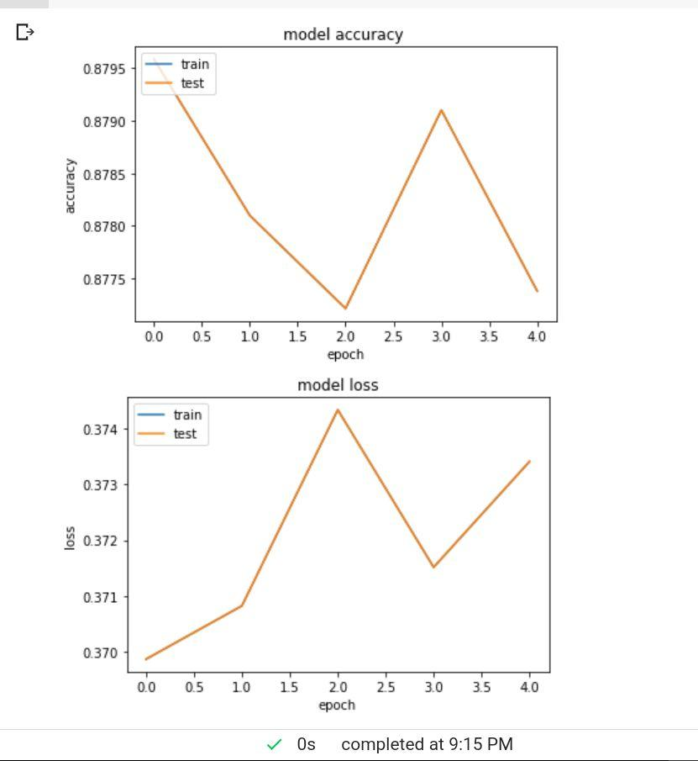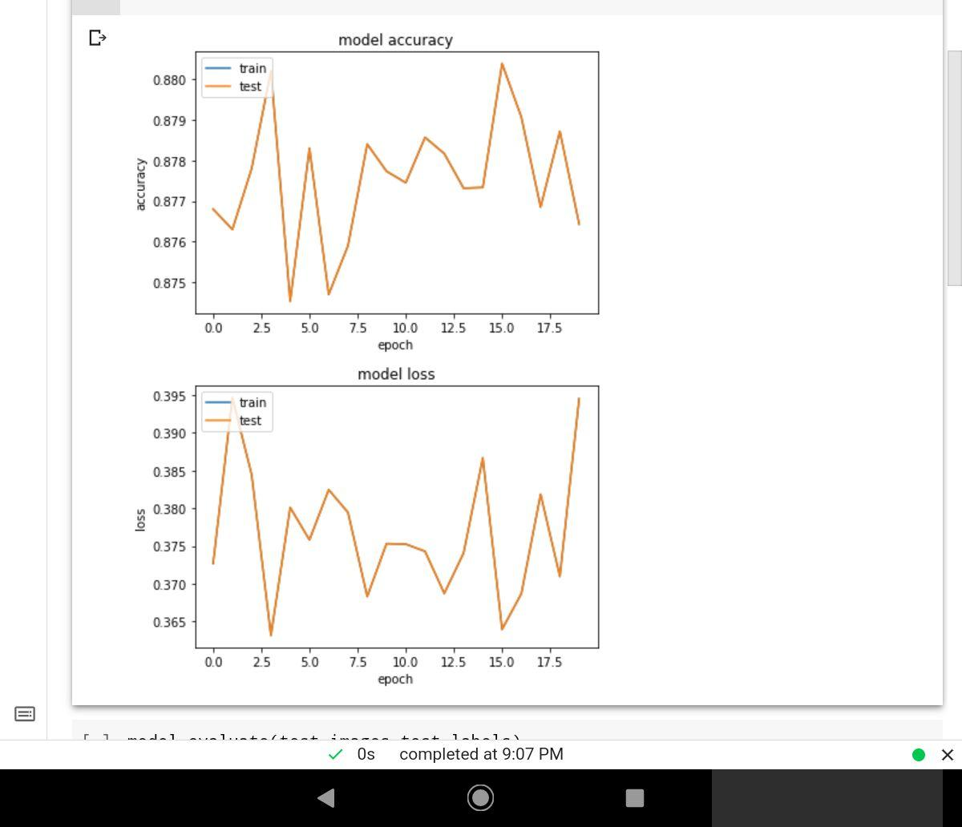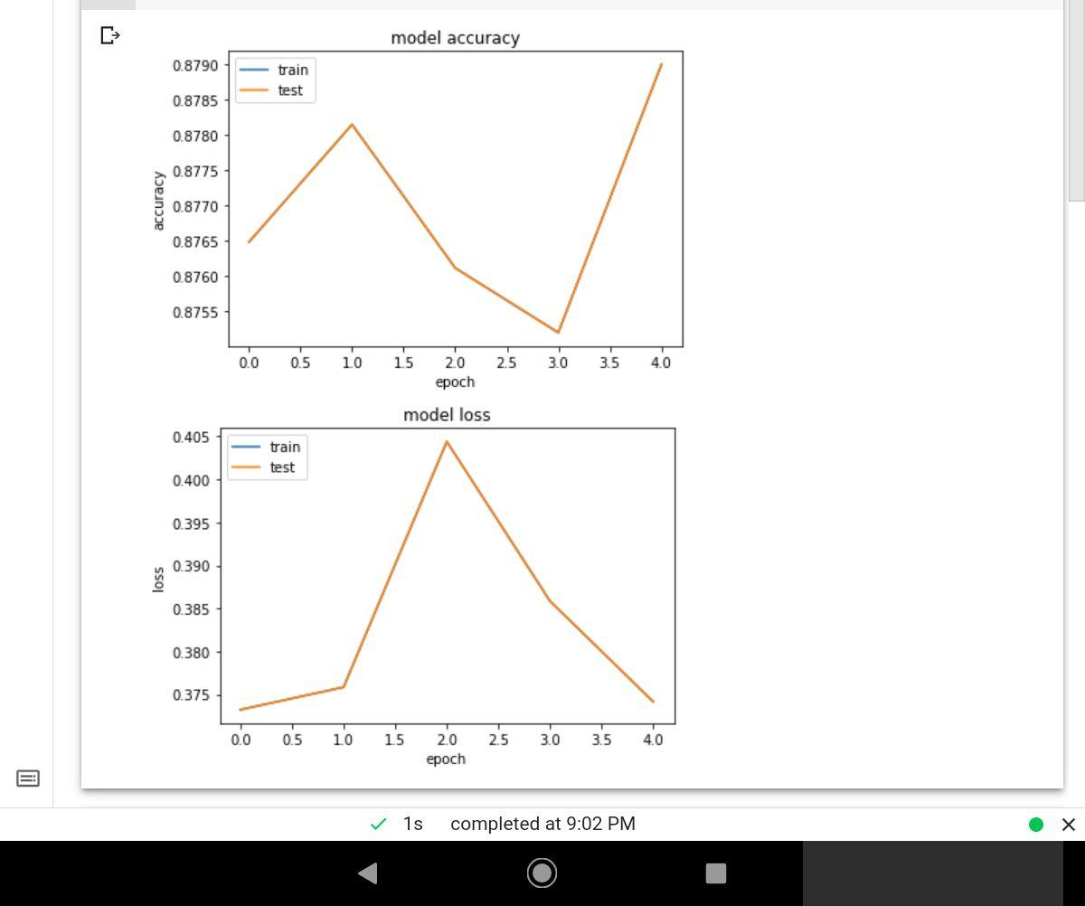

**How to improve**

More sophisticated hardware needs to be used to cater for the maximum number of epochs. This will ensure that not much time is spent on training the model. Also, more time needs to be employed to clean the data because it is the factor that perhaps most affects the performance of the model.

**Key Takeaways**

* When dealing with deep neural networks, more data is everything!